Maharaja Surajmal Institute of Technology, New Delhi-110058
Training & Placement Cell
Technical Session Report
Event Agenda | Technical Session on "AI Agents and LLM" by AI-Shala Technologies Pvt. Ltd.
Speaker | Mr. Bhaskar Gupta
Date and Time | 10-09-2026, 12:30 PM onwards
Venue | Lab 106, MSIT
Target Audience | 3rd Year B.Tech Students
Organized by | AI-Shala Technologies Pvt. Ltd. in association with the Training & Placement Cell, Maharaja Surajmal Institute of Technology
Total Participants | 60
Introduction
The Training & Placement Cell of Maharaja Surajmal Institute of Technology (MSIT), Janakpuri, Delhi, organized a Technical Session on “AI Agents and LLM” in collaboration with AI-Shala Technologies Pvt. Ltd. The session was conducted by Mr. Bhaskar Gupta, who introduced students to the fundamentals of Generative AI, Large Language Models (LLMs), and the emerging field of AI agents.
The session was attended by 60 students from the 3rd Year B.Tech programme and was held in Lab 106, MSIT, starting at 12:30 PM.
About AI-Shala Technologies Pvt. Ltd.
AI-Shala Technologies Pvt. Ltd. is a technology and training organization that works in the domain of Artificial Intelligence, focusing on upskilling students and professionals in areas such as Generative AI, Large Language Models, and AI agent-based systems. Through hands-on sessions and industry-oriented training, the organization aims to bridge the gap between academic learning and industry-relevant AI skills.
Objective of the Session
- To introduce students to the fundamentals of Generative AI and Large Language Models (LLMs).
- To explain the concept and working of Retrieval-Augmented Generation (RAG).
- To familiarize students with prompt engineering and its various techniques.
- To build a foundational understanding of AI agents and how single-agent and multi-agent systems function.
- To assess student learning through an interactive quiz conducted at the end of the session.
Key Topics Covered
- What is Generative AI
- Retrieval-Augmented Generation (RAG)
- Prompt Engineering
- Zero-shot, One-shot, and Two-shot Prompting
- Types of Prompt Engineering, including Chain-of-Thought (CoT) Prompting – where the AI is instructed to think step-by-step through a complex problem before arriving at the final answer
- AI Agents
- Single-Agent vs Multi-Agent Systems
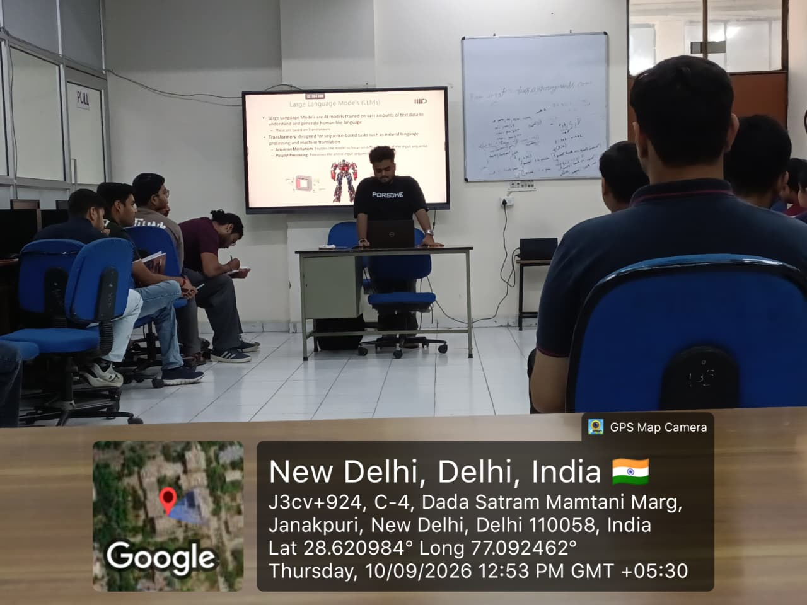
Session Overview
Mr. Bhaskar Gupta began the session by explaining the basics of Generative AI and how Large Language Models are trained and used to generate human-like text. He then walked students through the concept of Retrieval-Augmented Generation (RAG) and how it helps LLMs access external knowledge to produce more accurate and context-aware responses.
The speaker then moved on to prompt engineering, explaining how the way a prompt is framed significantly affects the quality of the AI's output. He covered Zero-shot, One-shot, and Two-shot prompting techniques, along with various types of prompt engineering – with special emphasis on Chain-of-Thought (CoT) prompting, wherein the AI is guided to reason step-by-step through a problem before giving its final answer.
In the latter half of the session, Mr. Gupta introduced the concept of AI agents – autonomous systems capable of performing tasks using LLMs – and explained the difference between single-agent and multi-agent architectures, along with their respective use cases.
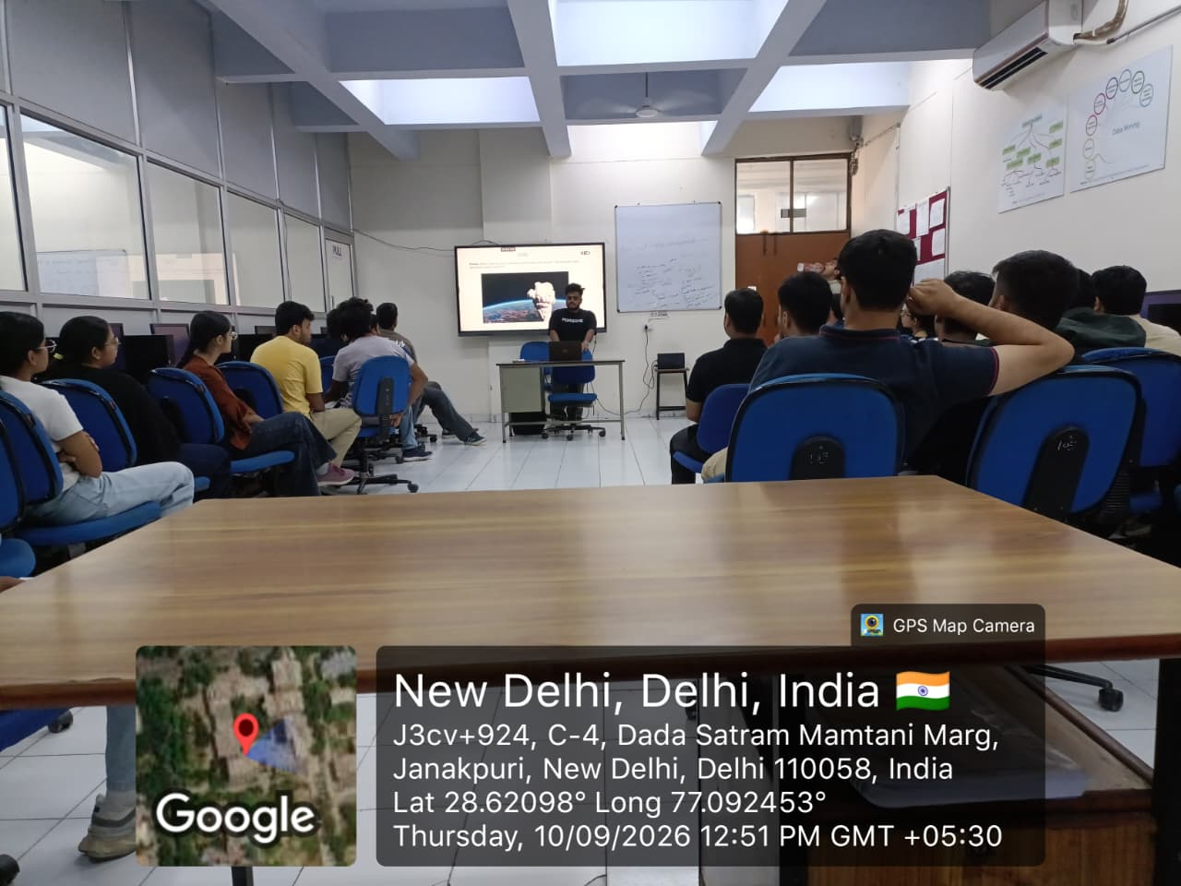
Student Interaction and Quiz
The session saw active participation from the students, who engaged with the speaker through questions on prompt engineering techniques and the practical applications of AI agents. Towards the end of the session, an interactive quiz was conducted to test the students' understanding of the concepts covered, including Generative AI, RAG, prompt engineering, and AI agents. The quiz added an engaging and competitive element to the session and helped reinforce the key learnings among the students.
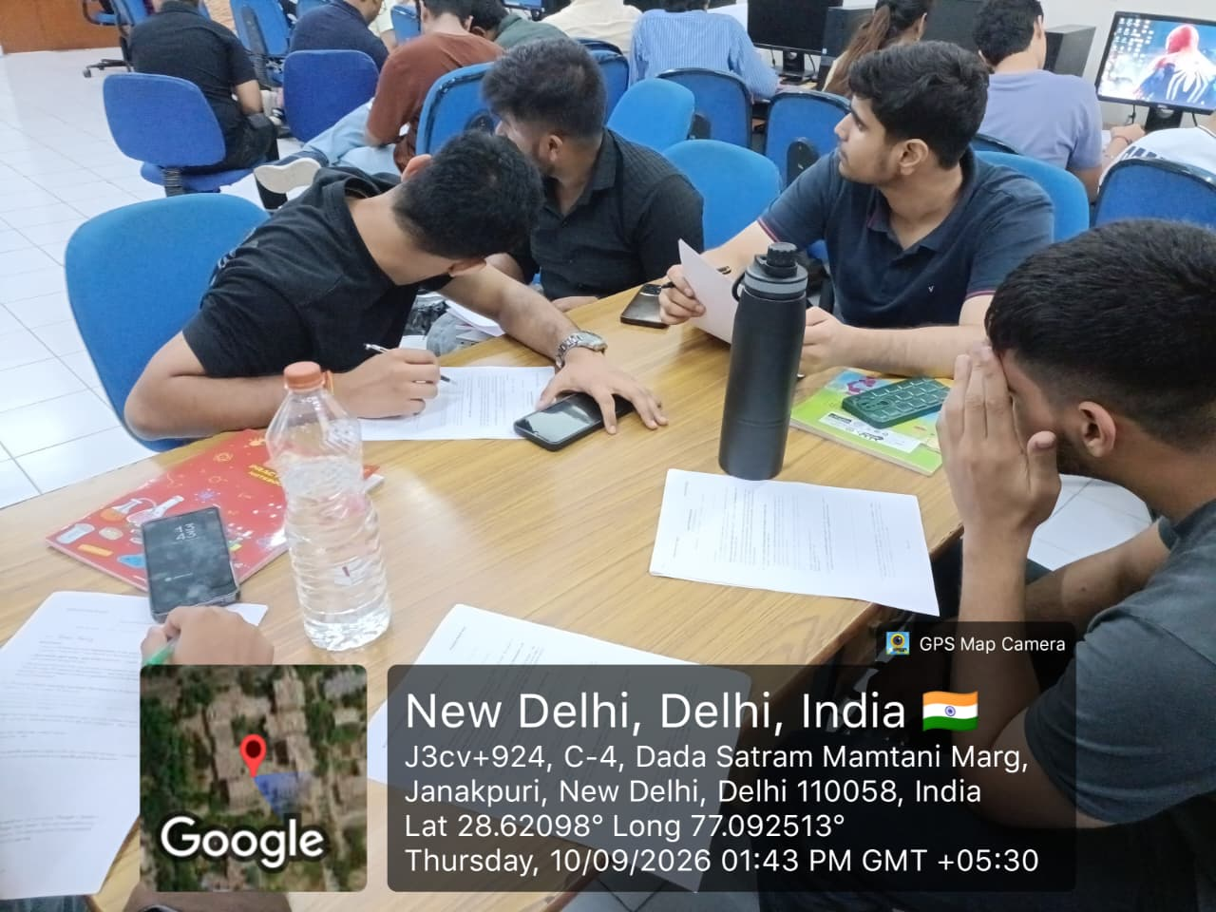
Conclusion
The Technical Session on “AI Agents and LLM” conducted by AI-Shala Technologies Pvt. Ltd. proved to be an informative and engaging experience for the 3rd Year students of MSIT. It gave students a strong conceptual foundation in Generative AI, prompt engineering, and AI agents, while the concluding quiz ensured active learning and better retention of the concepts discussed.
Acknowledgment
We extend our sincere gratitude to Mr. Bhaskar Gupta and AI-Shala Technologies Pvt. Ltd. for conducting this insightful session and sharing their expertise with the students. We also thank the Training & Placement Cell of MSIT for organizing this session and for their continuous efforts in enhancing the technical skill set of students.
Faculty Co-coordinators
Dr. Kavita Sheoran

Ms. Jyoti
Ms. Manju Dhull

HOD CSE (Morning Shift)
Dr. Naresh Kumar

