REPORT ON INDUSTRIAL VISIT TO
5th DeviceNext Smart Device Ecosystem Summit & Awards 2026
Venue: Crowne Plaza, Gurugram | Date: 11 September 2026

Event | 5th DeviceNext Smart Device Ecosystem Summit & Awards 2026
Date | 11 September 2026
Venue | Crowne Plaza, Gurugram
Theme | Reinvent. Rebuild. Rise.
Visit Type | Industrial Visit – Computer Science & Engineering
Students from College | 23
3rd Year Students | 15
4th Year Students | 8
Contest Result | 1st, 2nd and 3rd positions secured by college students

1. Introduction
As part of the academic and industry-exposure initiatives for the students of the Computer Science and Engineering Department, an industrial visit was organised to the 5th DeviceNext Smart Device Ecosystem Summit & Awards 2026 held at Crowne Plaza, Gurugram, on 11 September 2026. A total of 23 students from the Computer Science and Engineering branch participated in the visit, comprising 15 students from the 3rd year and 8 students from the 4th year. Students from other colleges also participated in the summit, providing an opportunity for inter-college interaction and professional networking.

2. About DeviceNext Summit & Awards 2026
DeviceNext is a technology-focused B2B media and industry platform covering areas such as mobile handsets, telecom, consumer technology, home appliances, lifestyle gadgets and accessories. The 5th edition of the DeviceNext Smart Device Ecosystem Summit & Awards 2026 brought together industry leaders, technology experts, innovators, manufacturers and ecosystem stakeholders to discuss the future of smart devices and connected technology.
The central theme of the 2026 summit was “Reinvent. Rebuild. Rise.” The programme covered major areas of the smart-device ecosystem, including gaming, smart homes, connected devices, smart accessories, consumer technology and electronics manufacturing. The summit also focused on the changing role of AI, IoT, connected experiences, product engineering, manufacturing and innovation in India.
The event provided a platform for students to observe how ideas and technologies discussed in classrooms are connected with real-world products, businesses and industry requirements. The summit also enabled participants to interact with professionals and understand emerging trends in the technology ecosystem.

3. Objectives of the Industrial Visit
- To provide students with direct exposure to the current technology and smart-device industry.
- To understand emerging trends in AI, IoT, connected devices, gaming, smart homes and consumer electronics.
- To bridge the gap between academic learning and practical industry requirements.
- To provide students with opportunities for professional networking and communication.
- To encourage students to participate in industry-oriented activities and build confidence.
- To understand the importance of innovation, product thinking, communication and professional presentation.

4. Student Participation and Exposure
The visit was attended by 23 CSE students from the college, including 15 students from the 3rd year and 8 students from the 4th year. During the summit, students attended industry discussions and gained exposure to professionals working across different segments of the technology and smart-device ecosystem. The presence of students and delegates from different colleges also created an environment for peer interaction, exchange of ideas and networking.
For CSE students in particular, the visit was valuable because it demonstrated that the technology industry extends beyond software development alone. Modern products increasingly combine software, hardware, AI, connectivity, user experience, data and manufacturing. This helped students develop a broader understanding of how their technical skills can contribute to real-world technology products and businesses.
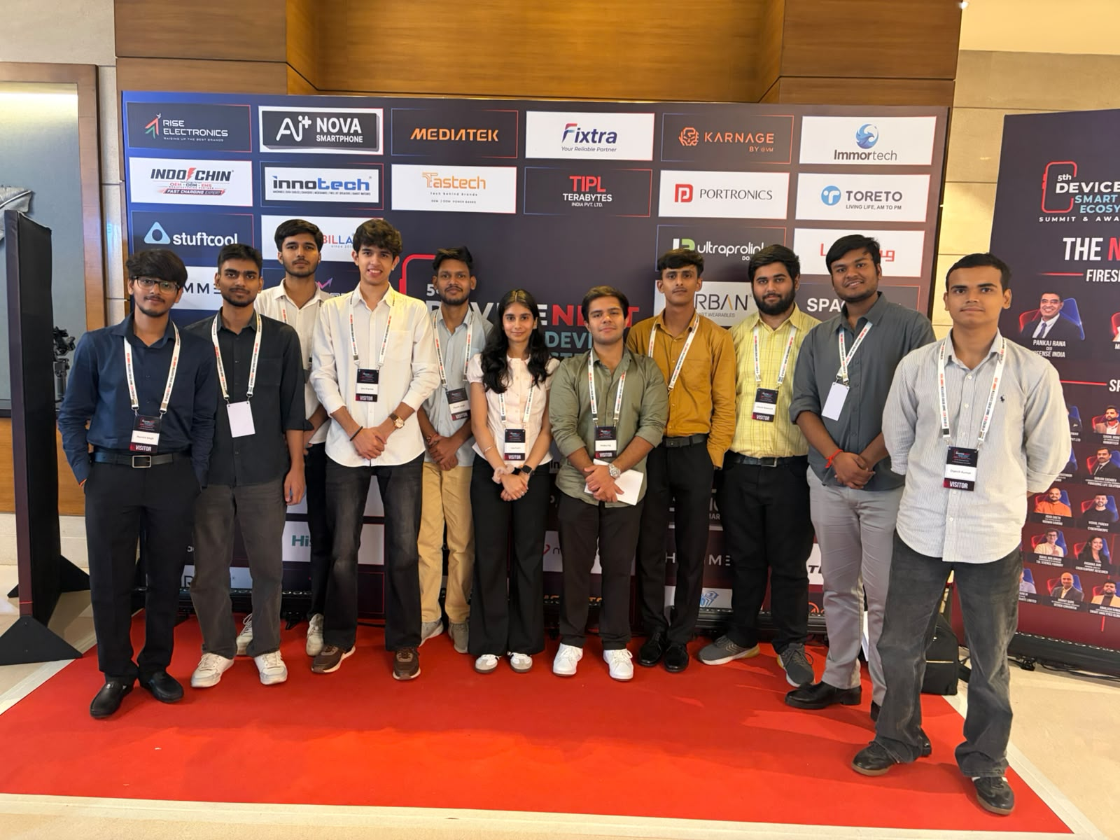

5. DeviceNext Contest and Student Achievement
A special social-media contest was also conducted as part of the DeviceNext Summit experience. Participants were encouraged to share their DeviceNext Summit experience on social-media platforms, particularly LinkedIn and Instagram, while tagging DeviceNext and using the designated event hashtag. The contest was designed to encourage students and delegates to communicate their experience professionally and create wider visibility for the summit.
As communicated during the contest, the final recognition was based on the reach/engagement achieved by the participants' LinkedIn posts along with their communication and interaction performance. This made the activity more than a conventional social-media posting exercise; it encouraged students to develop professional communication, content presentation, networking and personal-branding skills.
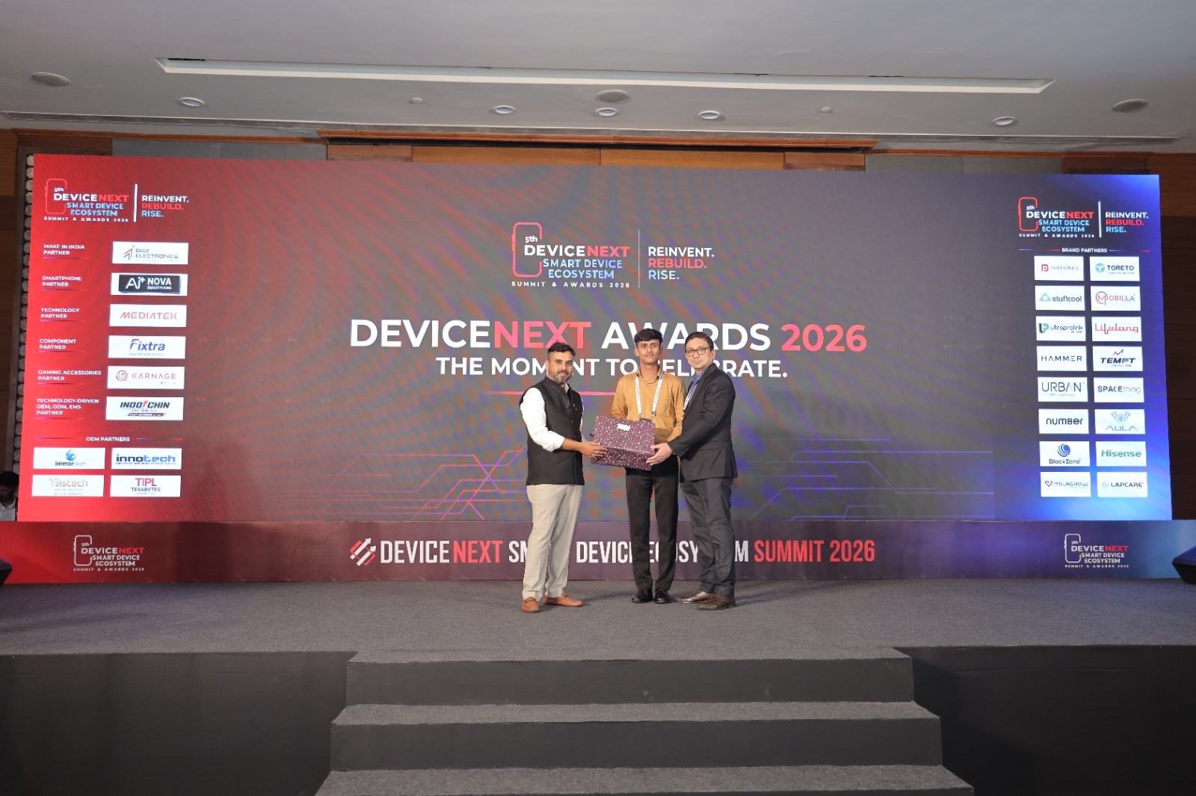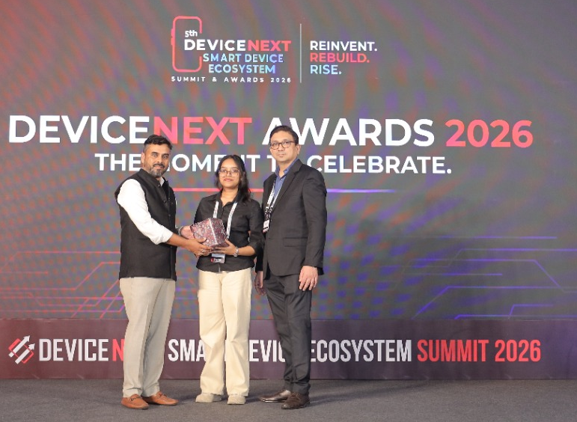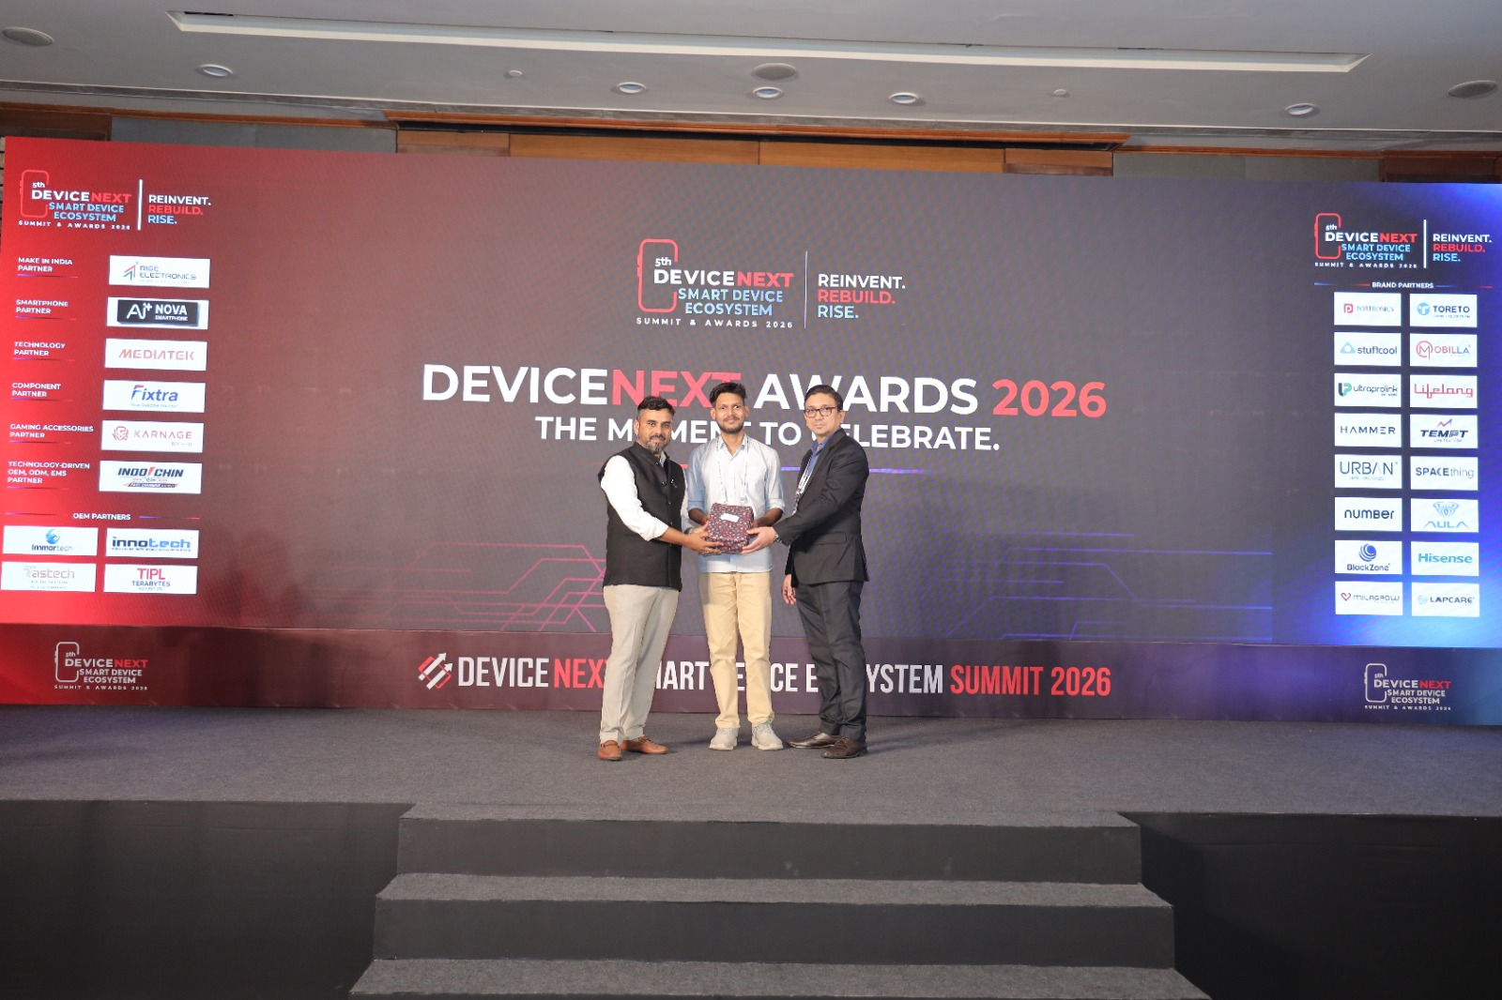

6. Winners of the Contest
Position | Student Name | Year / Class | College
1st Position | Harsh Deshwal | 3rd Year / CSE 3 | Maharaja Surajmal Institute of Technology
2nd Position | Purnima Varshney | 3rd Year / CSE 3 | Maharaja Surajmal Institute of Technology
3rd Position | Piyush | 3rd Year / CSE 4 | Maharaja Surajmal Institute of Technology
It is a matter of pride that all three positions in the contest were secured by students from the same college. The achievement reflects the students' active participation, communication ability, confidence and effective use of professional social-media platforms.

7. Recognition and Internship Opportunity
The first-position achievement was particularly significant as the organiser also extended an internship opportunity to the first-position student based on the student's performance and interaction during the event. This demonstrates the value of industry exposure and the possibility of converting extracurricular and professional activities into meaningful career opportunities.

8. Key Learnings from the Visit
- Students gained first-hand exposure to the smart-device and consumer-technology ecosystem.
- Students learned how AI, IoT, connected devices and emerging technologies are influencing modern products.
- The event improved awareness of industry expectations, professional communication and networking.
- The contest strengthened students' ability to create professional content and communicate their experiences effectively.
- Students understood the importance of personal branding and professional visibility on platforms such as LinkedIn.
- Interaction with students and professionals from different backgrounds encouraged knowledge sharing and confidence building.
- The visit helped students connect classroom concepts with real-world industry applications and career opportunities.

9. Overall Experience and Conclusion
The industrial visit to the 5th DeviceNext Smart Device Ecosystem Summit & Awards 2026 was a highly informative and enriching experience for the participating CSE students. The combination of industry interaction, technology-focused discussions, professional networking and the DeviceNext contest made the visit particularly valuable. Students were able to observe the rapidly changing technology landscape and understand the importance of technical knowledge together with communication, confidence and professional presentation.
The achievement of securing all three contest positions by students of the college was an additional highlight of the visit. The first-position student also receiving an internship opportunity from the organiser further demonstrated the practical value of such industry-academia exposure. Overall, the visit successfully contributed to students' technical awareness, communication skills, professional confidence and understanding of career opportunities in the technology industry.

